####################### Katalon Cucumber Report ( Jenkins Report) #####################

Prerequisite :: Ensure the availability of one Katalon project.

1. Open the Katalon project.
2. Click on Project -🡪Settings

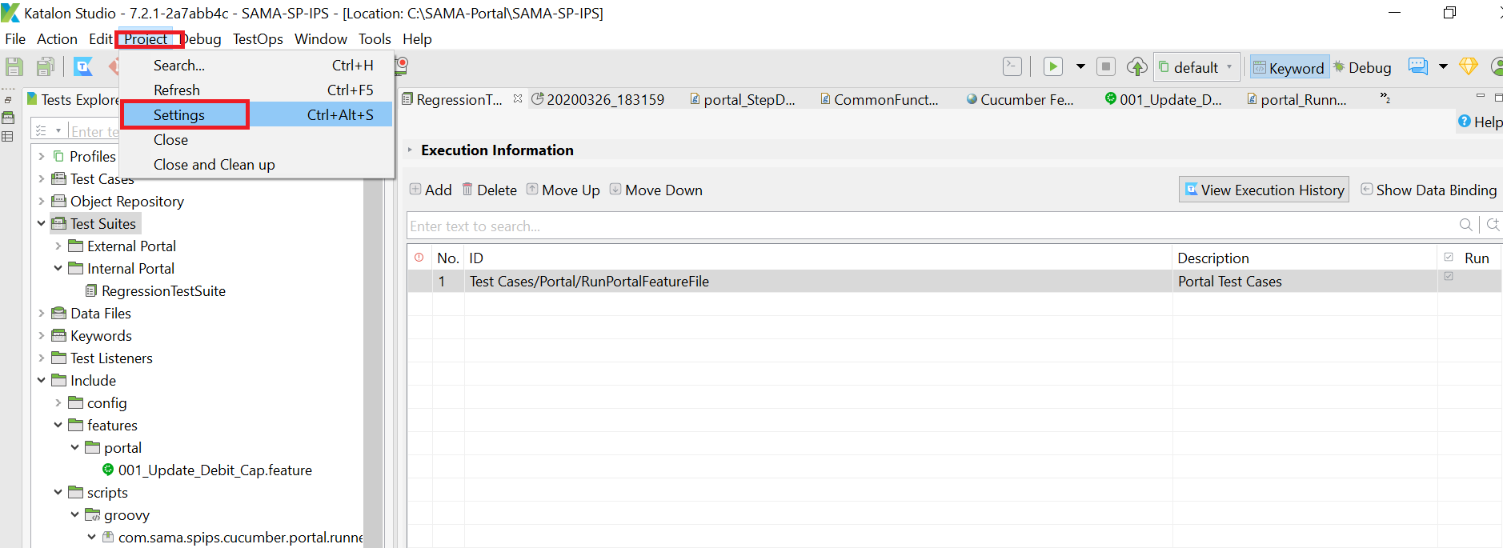

1. Click on External Libraries and then click on Add button.

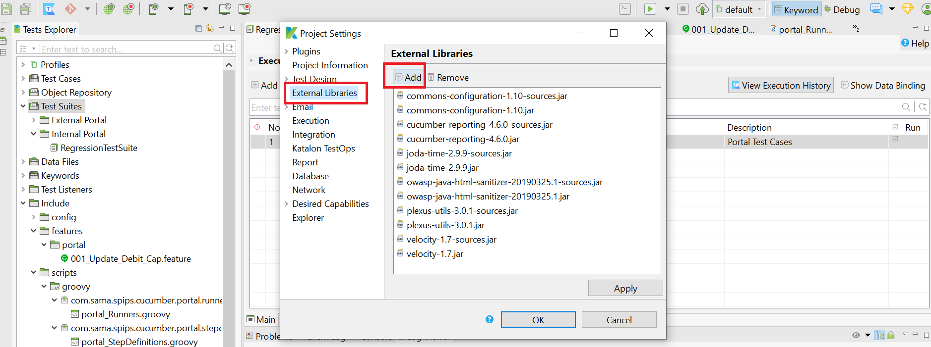

1. Download all below library and add one by one.

|  |  |  |
| --- | --- | --- |
|  |  |  |
|  |  |  |
|  |  |  |
|  |  |  |
|  |  |  |
|  |  |  |
|  |  |  |

**Note:** As an alternative, You can also put all report jars under driver folder(C:\SAMA-Portal\SAMA-SP-IPS\Drivers )

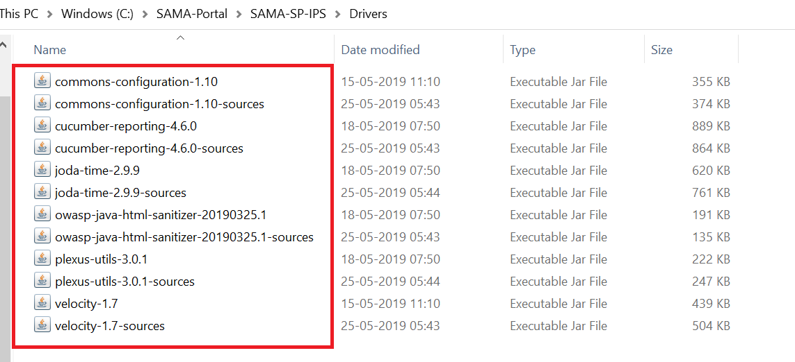

1. Write below line above the runner class name.

// Runner Packages

**import** org.junit.runner.RunWith;

**import** cucumber.api.CucumberOptions;

**import** cucumber.api.junit.Cucumber;

// com.sama.spips.cucumber.portal.stepdefs

//Report

**import** org.junit.AfterClass;

**import** net.masterthought.cucumber.Configuration;

**import** net.masterthought.cucumber.ReportBuilder;

**import** net.masterthought.cucumber.Reportable;

@RunWith(Cucumber.**class**)

@CucumberOptions(features = "Include/features/portal", glue =

"", plugin = ["pretty", "html:ReportFolder/Cucumber-StandardReport",

"json:ReportFolder/Cucumber-Report/cucumber.json"],

tags = [ "@DebitCap_Valid, @DebitCap_Valid1"]

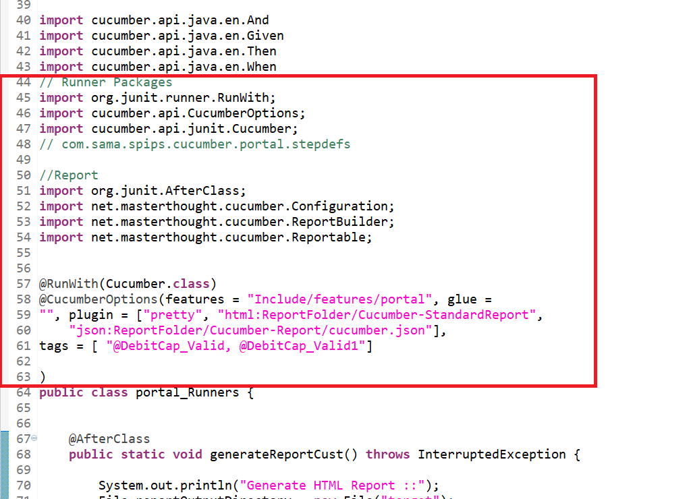

1. Write below code under the class name.

@AfterClass

**public** **static** **void** generateReportCust() **throws** InterruptedException {

System.out.println("Generate HTML Report ::");

File reportOutputDirectory = **new** File("target");

//Thread.sleep(60000);

List<String> jsonFiles = **new** ArrayList<>();

// File f = new

// File("C:\\HydroOttawa\\CCB-Upgrade\\ccbworkspace\\ccbupgrade-tests-automation\\ccbupgrade-tests-automation-poc\\target\\Cucumber-Report\\cucumber.json");

// System.out.println("Is file exist :: "+f.exists());

// System.out.println("Can execute :: "+f.canExecute());

jsonFiles.add(

"C:\\SAMA-Portal\\SAMA-SP-IPS\\ReportFolder\\Cucumber-Report\\cucumber.json");

// jsonFiles.add("C:\\HydroOttawa\\CCB-Upgrade\\ccbworkspace\\ccbupgrade-tests-automation\\ccbupgrade-tests-automation-poc\\Drivers\\cucumber.json");

// jsonFiles.add("cucumber-report-2.json");

String buildNumber = "1";

String projectName = "SAMA Portal";

// boolean runWithJenkins = true;

Configuration configuration = **new** Configuration(reportOutputDirectory, projectName);

// optional configuration - check javadoc

// configuration.setRunWithJenkins(runWithJenkins);

configuration.setBuildNumber(buildNumber);

// additional metadata presented on main page

configuration.addClassifications("Operating System", System.getProperty("os.name"));

//configuration.addClassifications("Browser", POC_Step_Definition.browser);

configuration.addClassifications("Java", System.getProperty("java.version"));

configuration.addClassifications("Selenium", "3.11");

configuration.addClassifications("Cucumber", "4.2.0");

// optionally add metadata presented on main page via properties file

// List<String> classificationFiles = new ArrayList<>();

// classificationFiles.add("properties-1.properties");

// classificationFiles.add("properties-2.properties");

// configuration.addClassificationFiles(classificationFiles);

ReportBuilder reportBuilder = **new** ReportBuilder(jsonFiles, configuration);

Thread.sleep(1000);

**try** {

reportBuilder.generateReports();

}

**catch** (Exception e) {

jsonFiles.add(

"C:\\SAMA-Portal\\SAMA-SP-IPS\\ReportFolder\\Cucumber-Report\\cucumber.json");

ReportBuilder reportBuilder1 = **new** ReportBuilder(jsonFiles, configuration);

reportBuilder1.generateReports();

}

}

1. After Running the script from runner file, the cucumber-html-reports folder will get generated under target folder.